

**Evidence Gathering Document for SQA Level 8 Professional Developer Award.**

This document is designed for you to present your screenshots and diagrams relevant to the PDA and to also give a short description of what you are showing to clarify understanding for the assessor.

Each point that required details the Assessment Criteria (What you have to show) along with a brief description of the kind of things you should be showing.

Please fill in each point with screenshot or diagram and description of what you are showing.

**Week 2**

| Unit | Ref | Evidence |  |
| --- | --- | --- | --- |

|  |  |  |
| --- | --- | --- |
| I&T | I.T.5 | Demonstrate the use of an array in a program. Take screenshots of:  *An array in a program  *A function that uses the array  *The result of the function running |
|  |  | **Description:** |

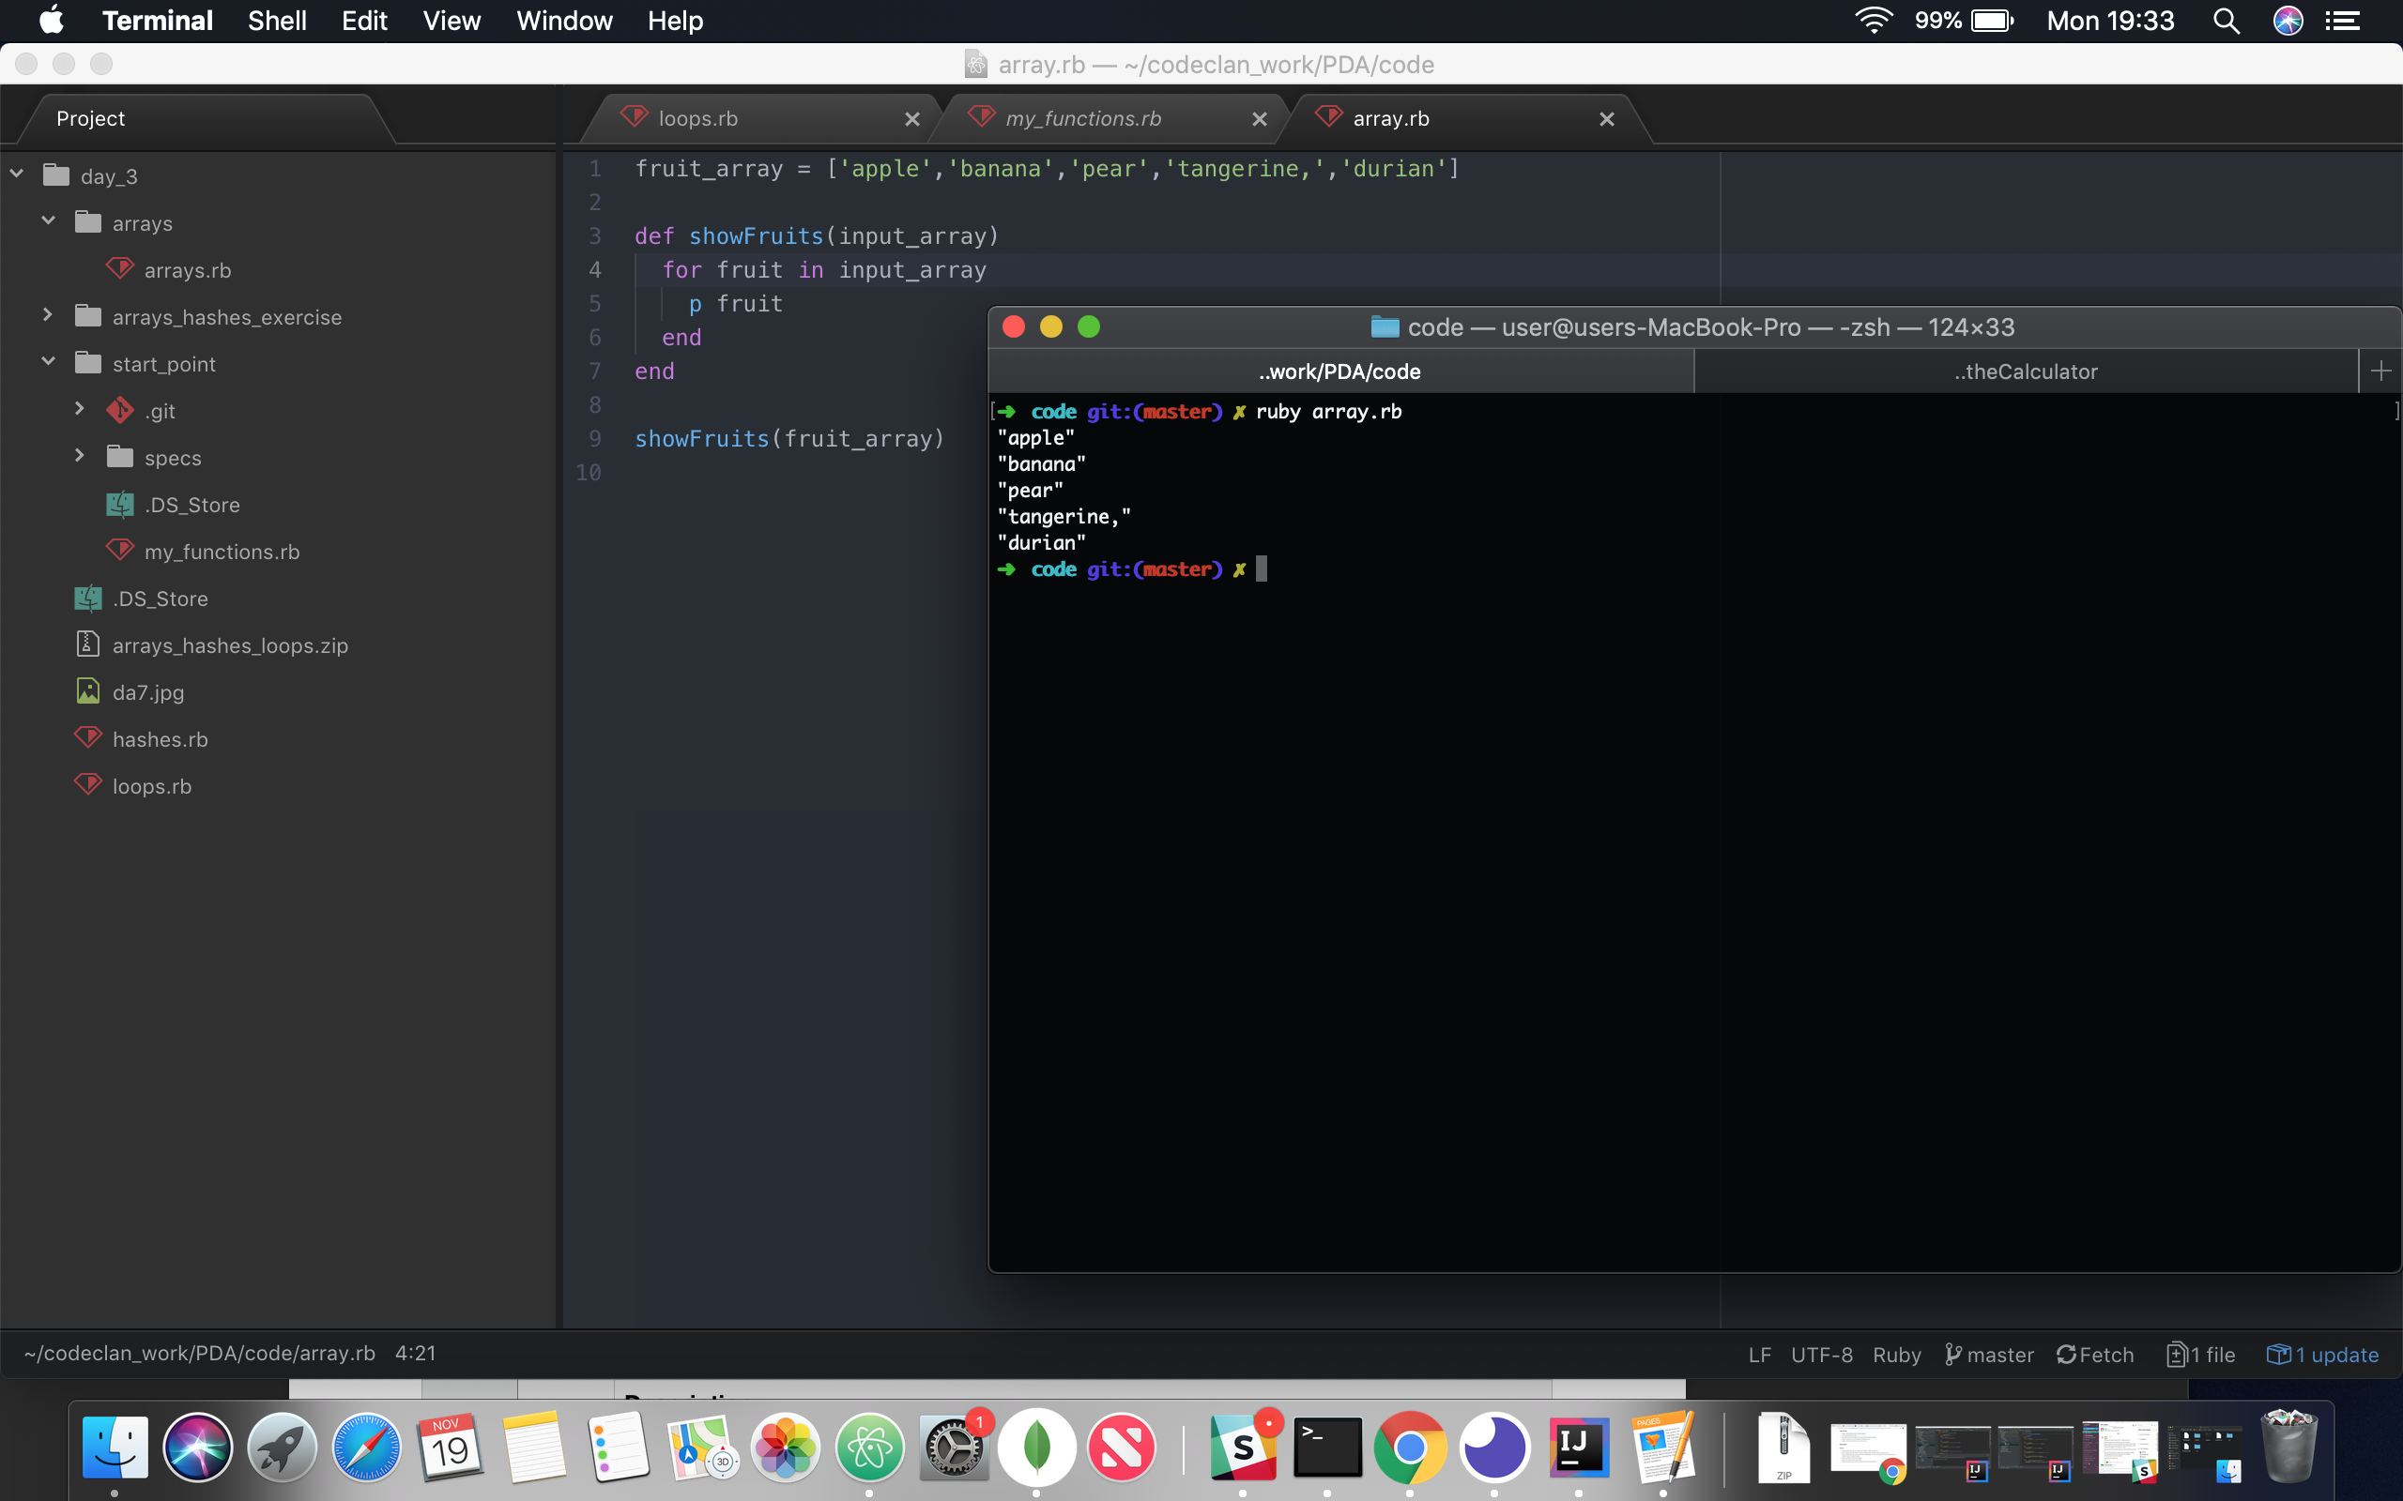

This is a basic array of fruits. When the function is called, and the fruit array is passed in, it loops through each fruit in the array and prints it to the screen.

| Unit | Ref | Evidence |  |
| --- | --- | --- | --- |

|  |  |  |
| --- | --- | --- |
| I&T | I.T.6 | Demonstrate the use of a hash in a program. Take screenshots of:  *A hash in a program  *A function that uses the hash  *The result of the function running |
|  |  | **Description:** |

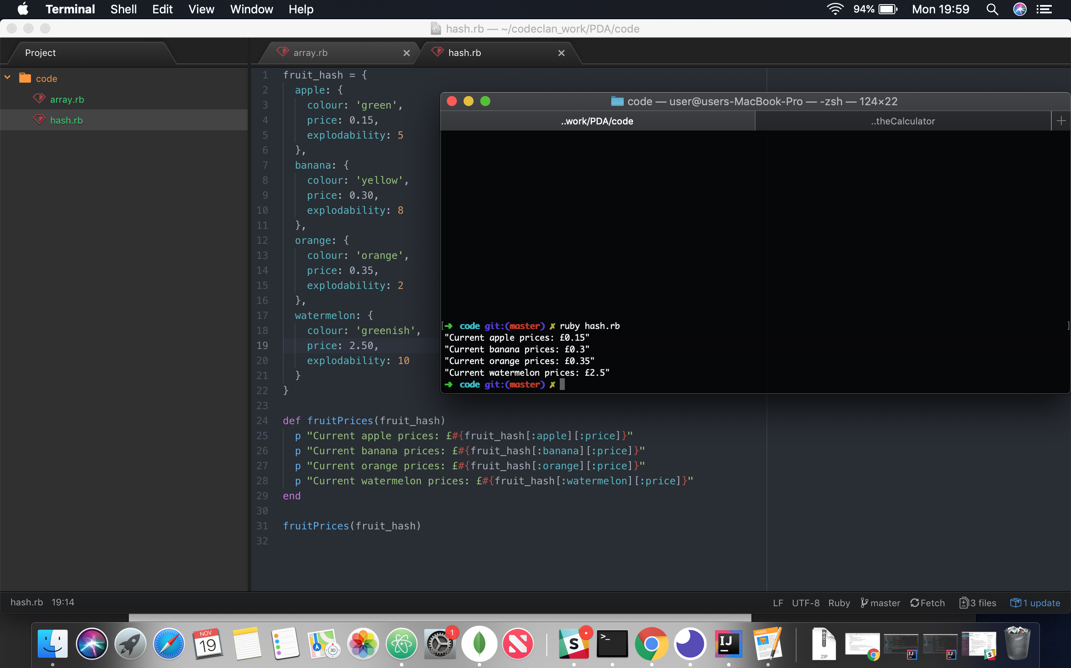

This hash stores a variety of information about various fruits. When the function fruitPrices is called, it accesses the price of each fruit and displays it in a list.

**Week 3**

| Unit | Ref | Evidence |  |
| --- | --- | --- | --- |

|  |  |  |
| --- | --- | --- |
| I&T | I.T.3 | Demonstrate searching data in a program. Take screenshots of:  *Function that searches data  *The result of the function running |
|  |  | **Description:** |

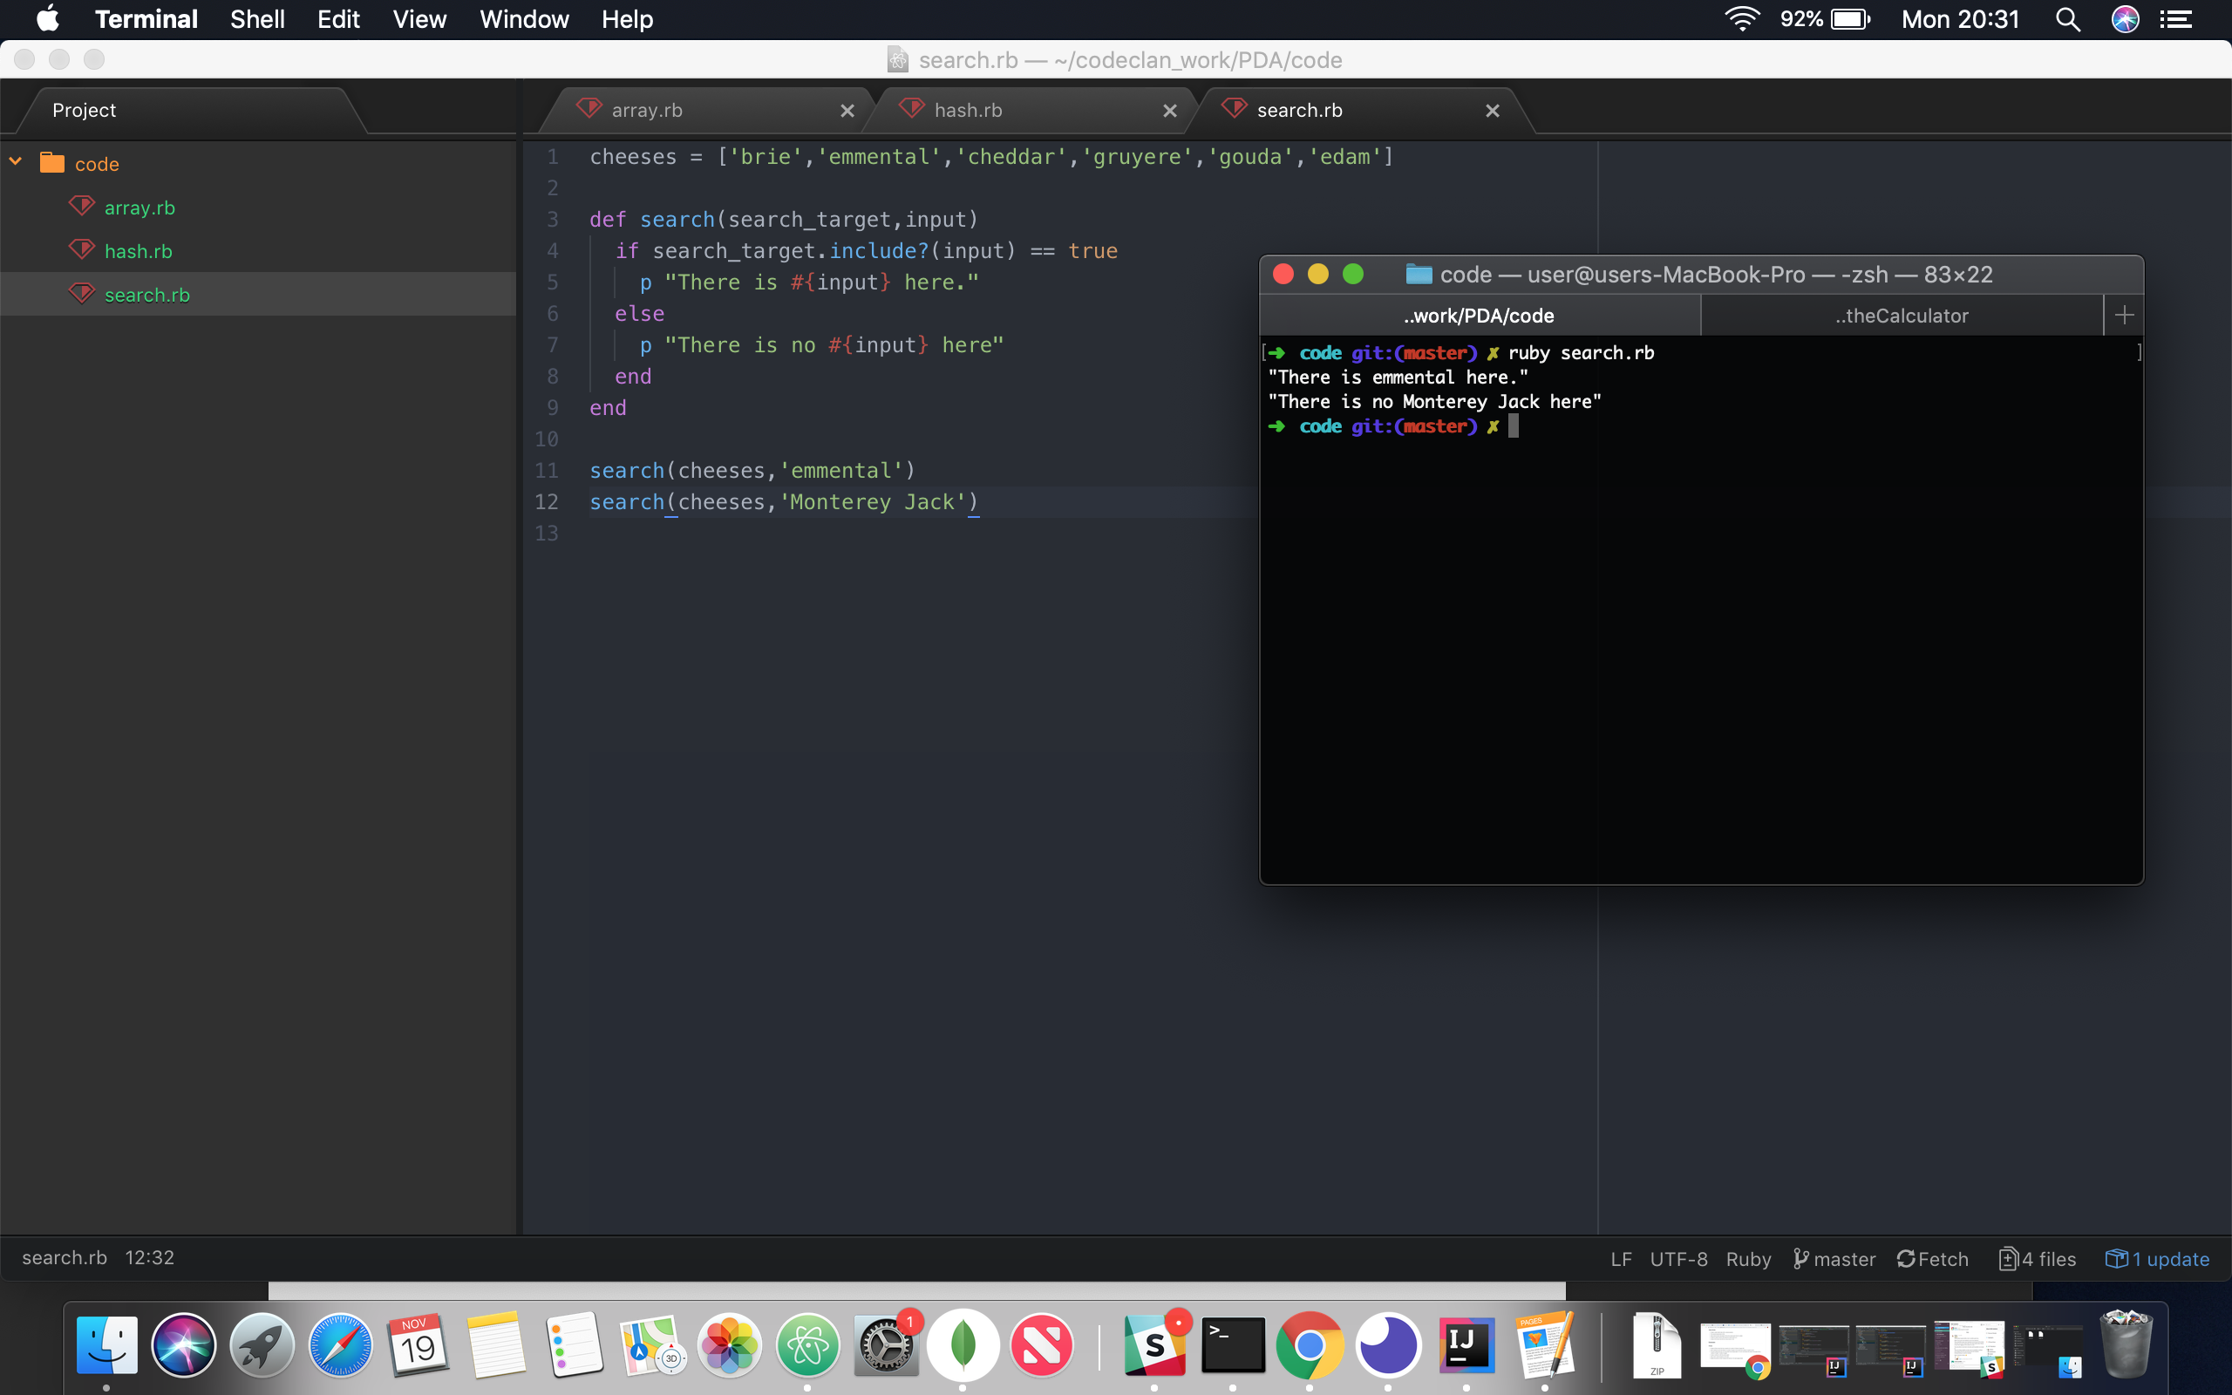

This function is a basic search. Any array can be sent into it, with any input, so it can be used for various circumstances. In this case, the function is passed an array of cheeses and a string. It searches for a match and displays a relevant message dependant on the result.

| Unit | Ref | Evidence |  |
| --- | --- | --- | --- |

|  |  |  |
| --- | --- | --- |
| I&T | I.T.4 | Demonstrate sorting data in a program. Take screenshots of:  *Function that sorts data  *The result of the function running |
|  |  | **Description:** |

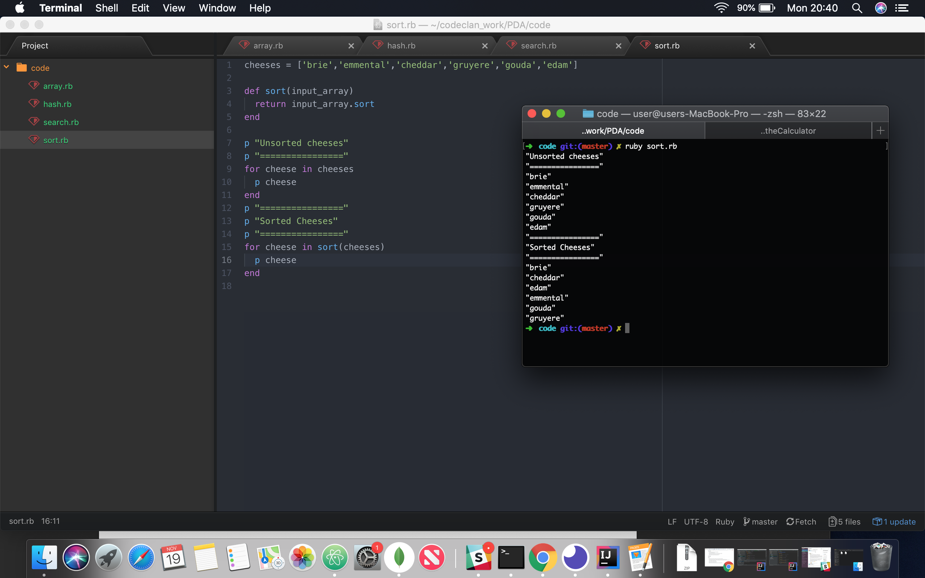

This function takes in the same array of cheeses and sorts them alphabetically, returning the newly sorted array. It is then printed out in the new order.

**Week 5 and 6**

| Unit | Ref | Evidence |  |
| --- | --- | --- | --- |

|  |  |  |
| --- | --- | --- |
| A&D | A.D.1 | A Use Case Diagram |
|  |  | **Description:** |

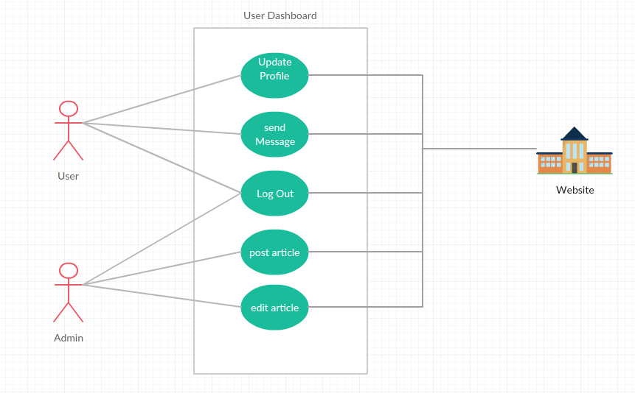

This is a Use Case diagram for a basic web user dashboard. A user can update profile, send messages, and an admin can post or edit an article. Both users can log out.

| Unit | Ref | Evidence |  |
| --- | --- | --- | --- |

|  |  |  |
| --- | --- | --- |
| A&D | A.D.2 | A Class Diagram |
|  |  | **Description:** |

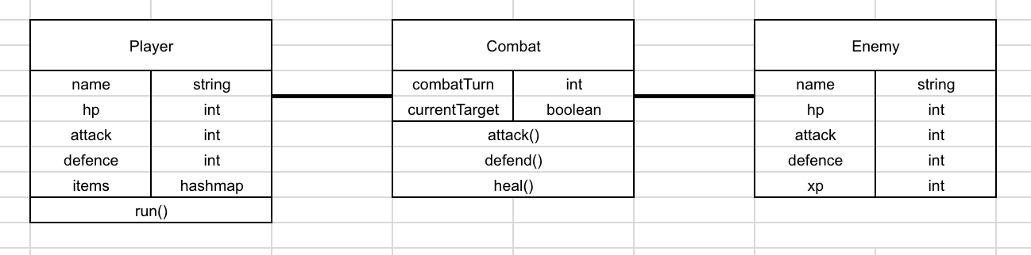

This is a class diagram for a basic turn based RPG. The player and enemy have several stats, with the player having an additional hash map to store collected items, and a player-specific function to allow them to leave a combat.

The combat class itself tracks what turn the combat is at, and whether the player or enemy is currently taking their turn, applying combat-specific functions to whoever is currently taking a turn.

| Unit | Ref | Evidence |  |
| --- | --- | --- | --- |

|  |  |  |
| --- | --- | --- |
| A&D | A.D.3 | An Object Diagram |
|  |  | **Description:** |

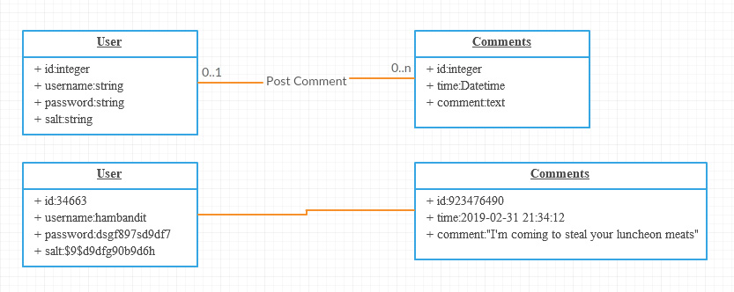

This is an object diagram for a basic comment system. The user has an id, username, and password with salt. The comment has an id, a time of posting and the comment body.

| Unit | Ref | Evidence |  |
| --- | --- | --- | --- |

|  |  |  |
| --- | --- | --- |
| A&D | A.D.4 | An Activity Diagram |
|  |  | **Description:** |

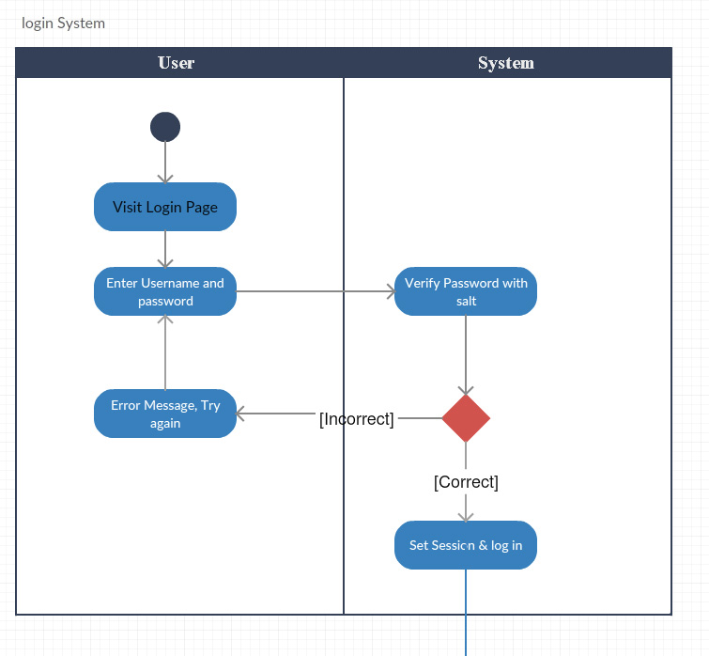

The activity diagram shows the process of a login. A user would visit a specific area of the site to log in. They would be prompted for their username and password. The system then takes the input password and username, retrieves the password and salt for that username, then checks it matches the actual password stored in the database.

If it matches, the user has session variables set and is logged in. Otherwise they are prompted to re-enter their details.

| Unit | Ref | Evidence |  |
| --- | --- | --- | --- |

|  |  |  |
| --- | --- | --- |
| A&D | A.D.6 | Produce an Implementations Constraints plan detailing the following factors:  *Hardware and software platforms  *Performance requirements  *Persistent storage and transactions  *Usability  *Budgets  *Time |
|  |  | **Description:** |



| Unit | Ref | Evidence |  |
| --- | --- | --- | --- |

|  |  |  |
| --- | --- | --- |
| P | P.5 | User Site Map |
|  |  | **Description:** |

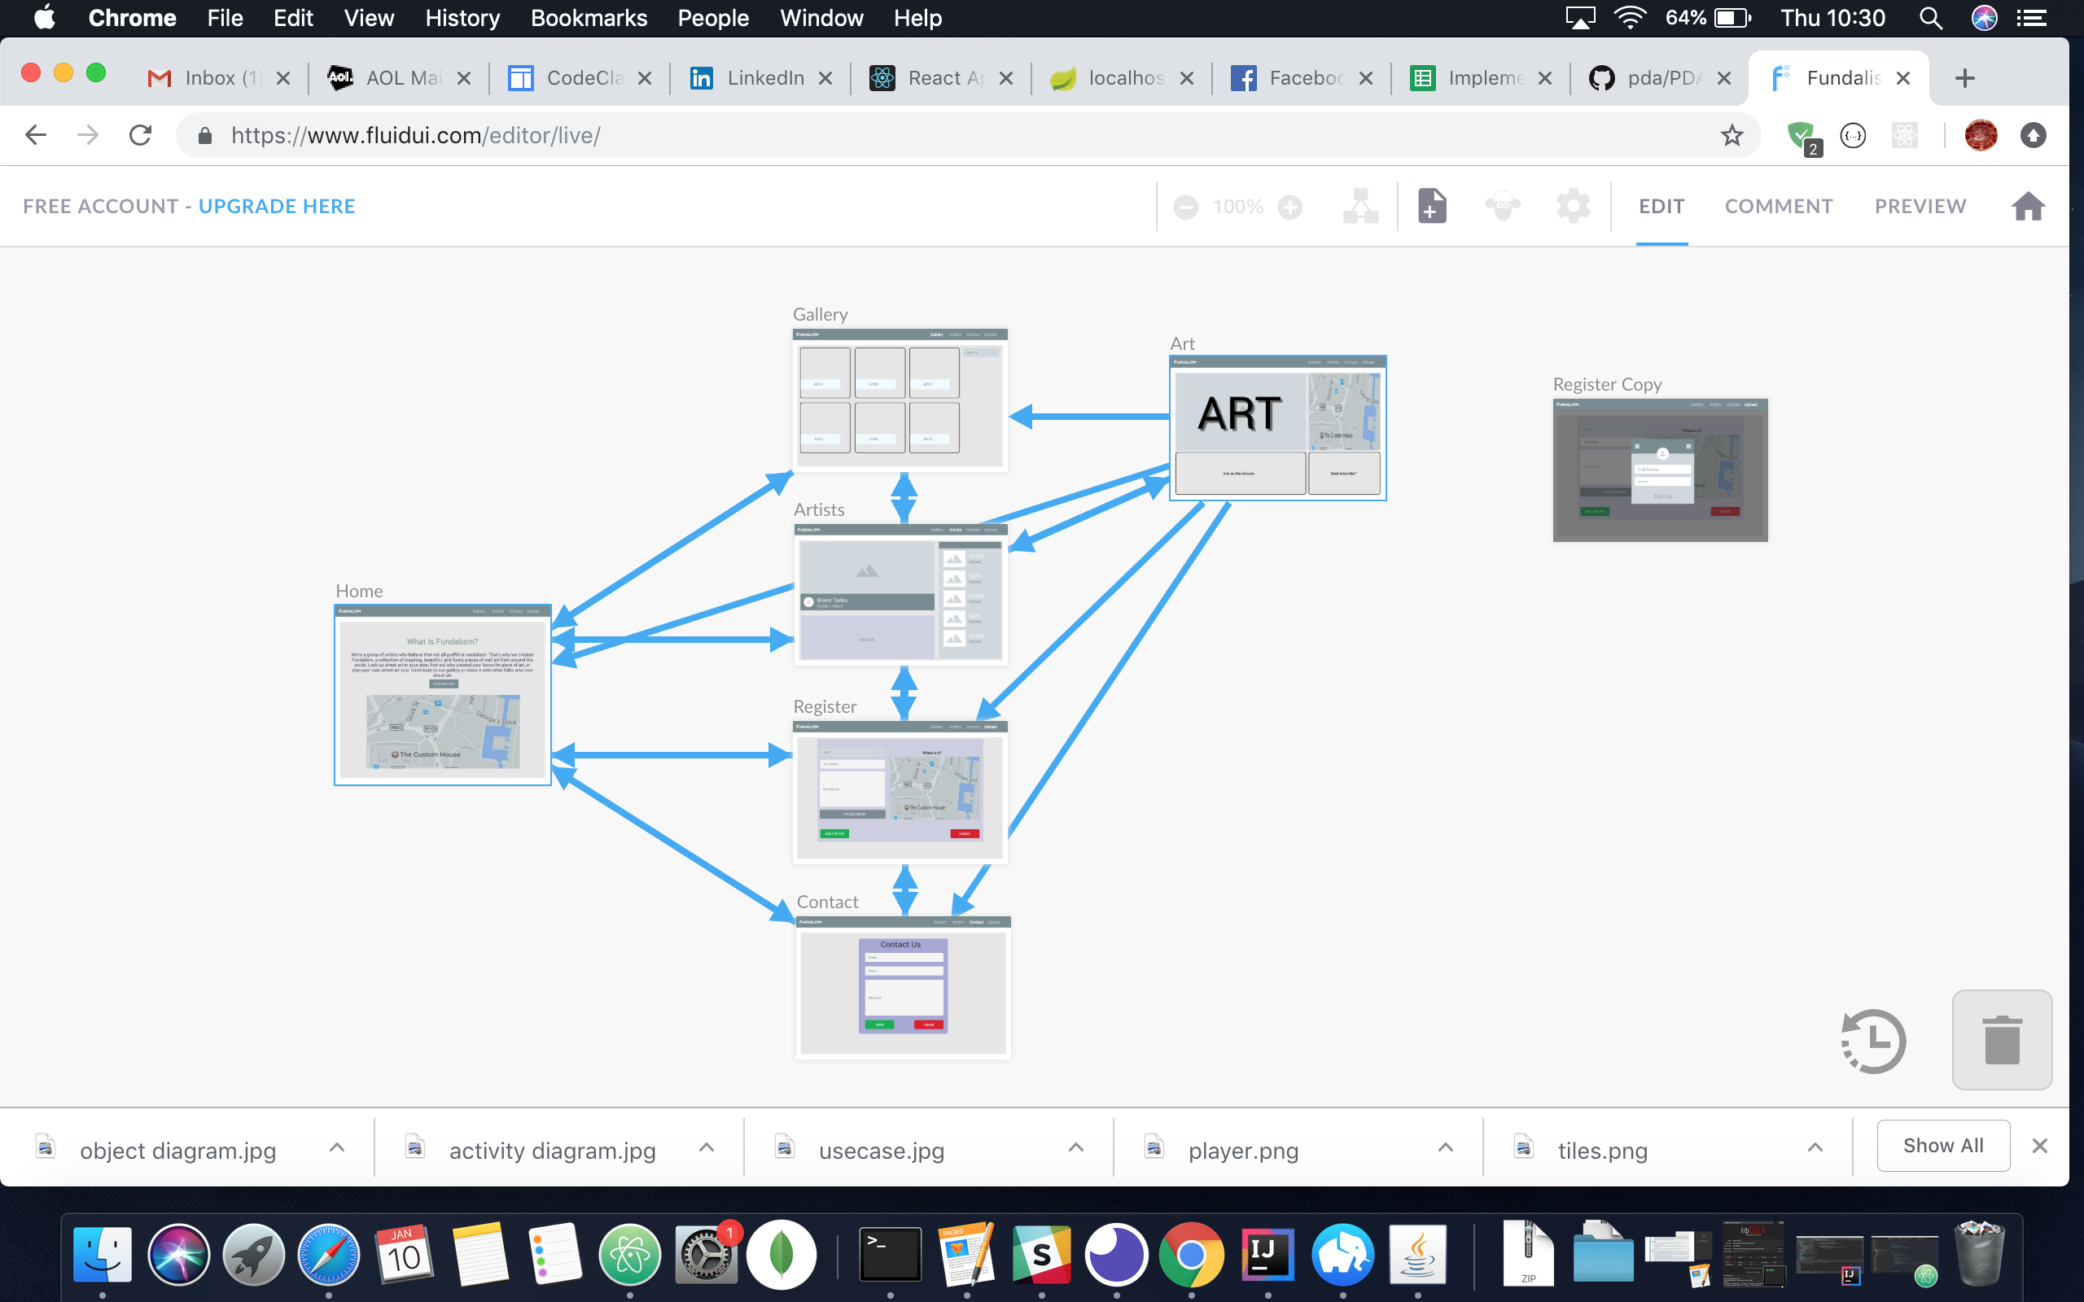

This is the wireframe for the final project for Fundalism. It shows all the pages along with arrows describing the navigation between pages.

| Unit | Ref | Evidence |  |
| --- | --- | --- | --- |

|  |  |  |
| --- | --- | --- |
| P | P.6 | 2 Wireframe Diagrams |
|  |  | **Description:** |

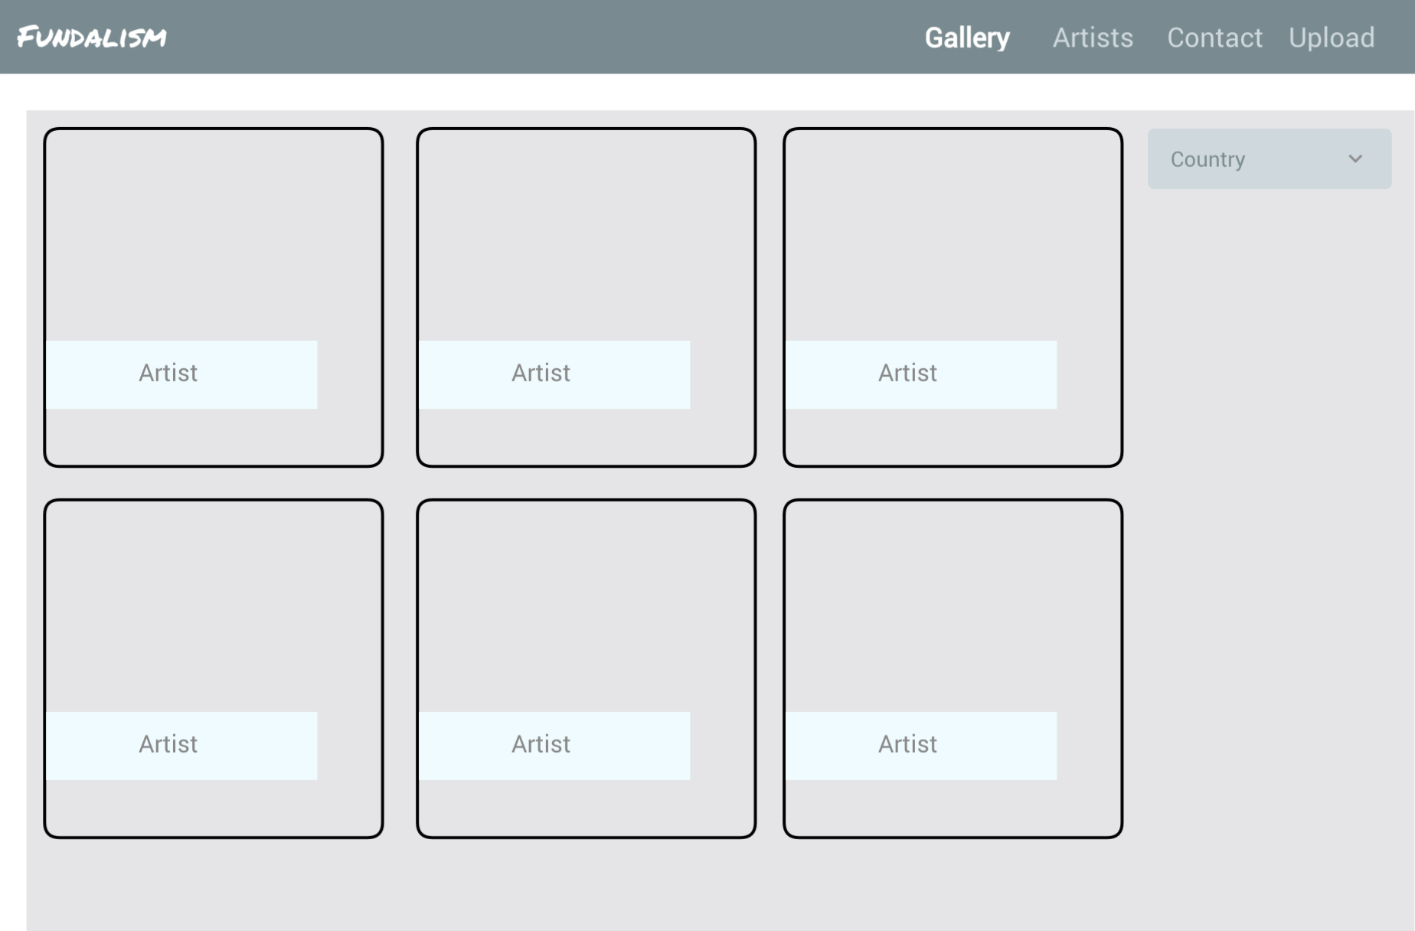

These wireframes are taken from the Fundalism Project. Even though they look like the actual design, it uses FluidUI, which is an interactive wire framing tool that also doubles as an interactive prototype, so you can get user feedback at the wireframing stage.

This interactive prototype can be found here

<https://www.fluidui.com/editor/live/preview/cF9SVW1yZzZEUVdGWE4ySGNYcTlpYlJmbVhTR0RQZEJlMw==>

| Unit | Ref | Evidence |  |
| --- | --- | --- | --- |

|  |  |  |
| --- | --- | --- |
| P | P.10 | Example of Pseudocode used for a method |
|  |  | **Description:** |

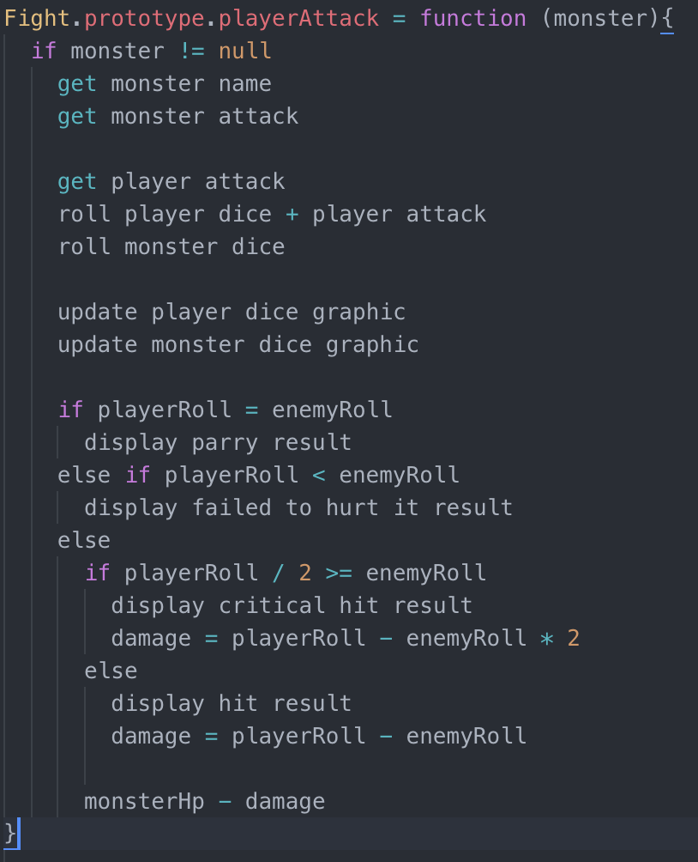

This is part of the Lost Prince project. The section of pseudocode relates to a method that handles combat logic. Both player and enemy must roll a dice, and the results checked to ascertain that our of combats result.

| Unit | Ref | Evidence |  |
| --- | --- | --- | --- |

|  |  |  |
| --- | --- | --- |
| P | P.13 | Show user input being processed according to design requirements. Take a screenshot of:  * The user inputting something into your program  * The user input being saved or used in some way |
|  |  | **Description:** |

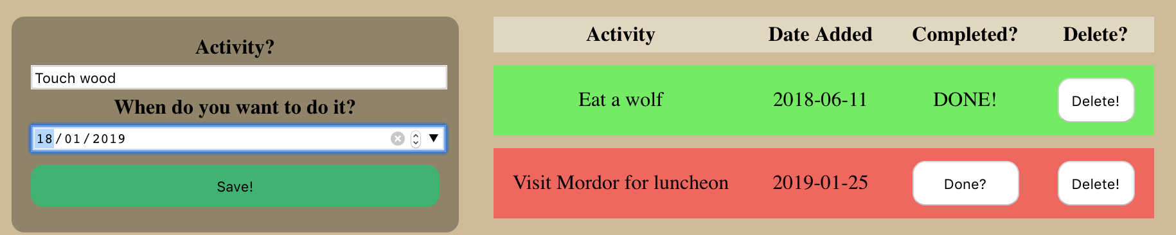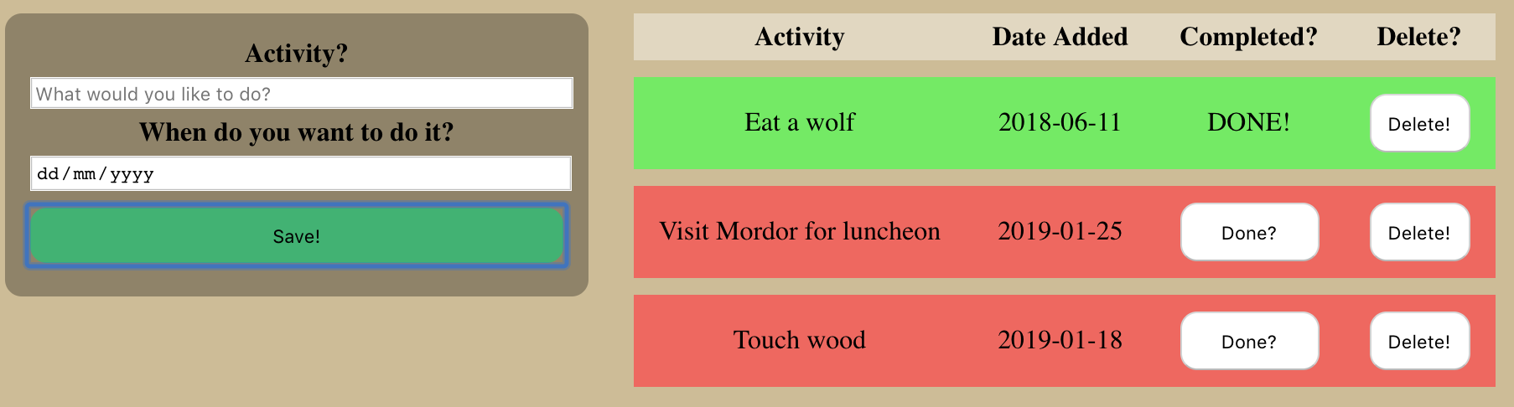

A simple activity tracker that allows a user to add to a Bucket List and then mark off the achieved items. The user can add in the activity and a date they want to do it by.

The app is in Javascript, while the data is stored in MongoDb.

| Unit | Ref | Evidence |  |
| --- | --- | --- | --- |

|  |  |  |
| --- | --- | --- |
| P | P.14 | Show an interaction with data persistence. Take a screenshot of:  * Data being inputted into your program  * Confirmation of the data being saved |
|  |  | **Description:** |

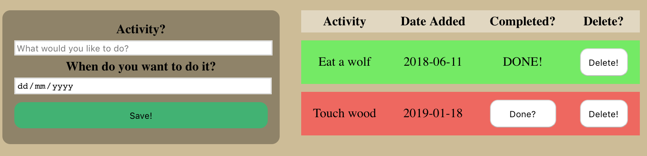

Following on from the previous set of screenshots, the user can also delete an item from the list. This modifies the database entry, saving the changed data.

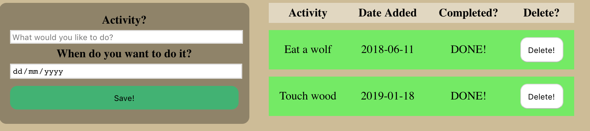

| Unit | Ref | Evidence |  |
| --- | --- | --- | --- |

|  |  |  |
| --- | --- | --- |
| P | P.15 | Show the correct output of results and feedback to user. Take a screenshot of:  * The user requesting information or an action to be performed  * The user request being processed correctly and demonstrated in the program |
|  |  | **Description:** |

Staying with the same app, an item on the bucket list can be updated as having been completed. Again, this updates a boolean field in the database. This is activated by clicking a button. To show the task has been updated, the background of the item turns green to signify a positive change, and the word “DONE!” Shows up in large letters in case the user missed all the positive green.

There is no option to undo the item. What has been done must stay done.

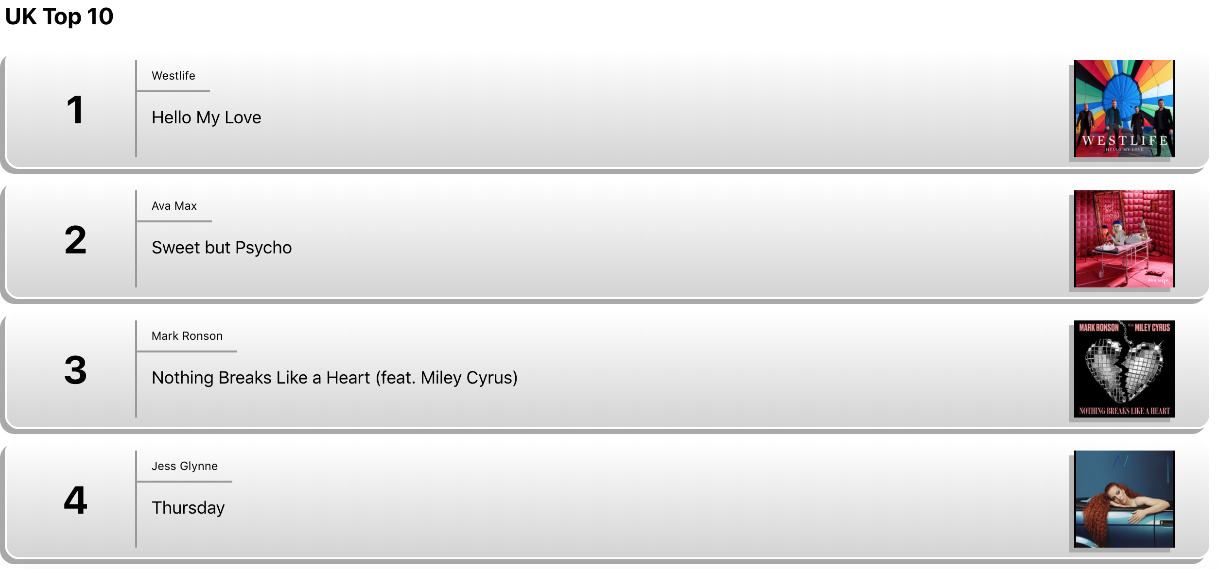

| Unit | Ref | Evidence |  |
| --- | --- | --- | --- |

|  |  |  |
| --- | --- | --- |
| P | P.11 | Take a screenshot of one of your projects where you have worked alone and attach the Github link. |
|  |  | **Description:** |

<https://github.com/smelge/react_uk_top_10_charts>

This was a short project to use React, Javascript and an API to populate a list using the UK top 10 chart from iTunes.

| Unit | Ref | Evidence |  |
| --- | --- | --- | --- |

|  |  |  |
| --- | --- | --- |
| P | P.12 | Take screenshots or photos of your planning and the different stages of development to show changes. |
|  |  | **Description:** |

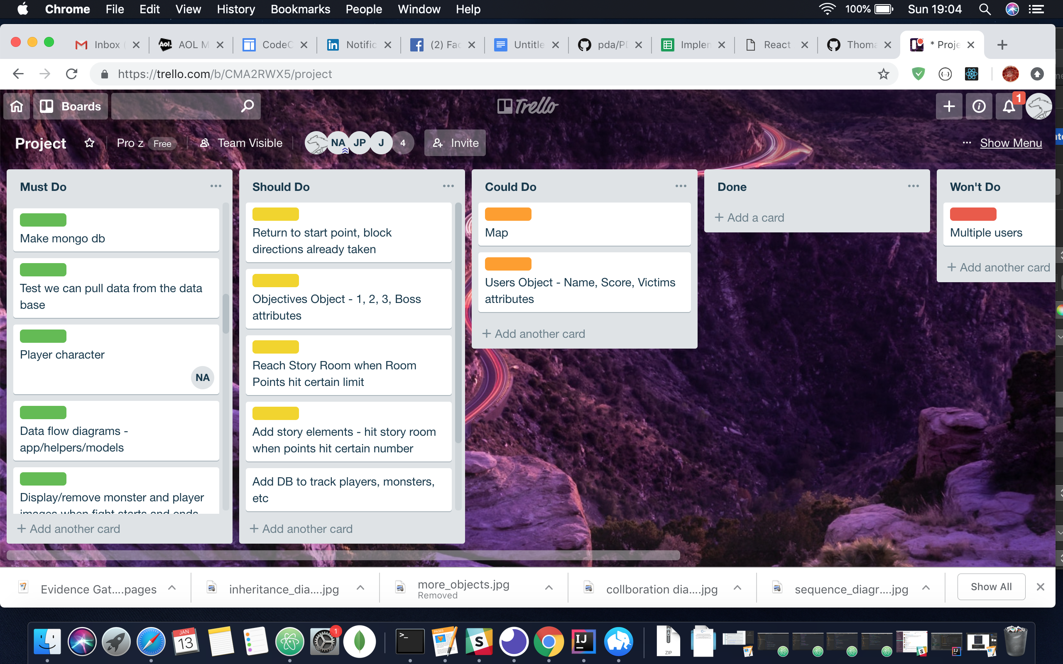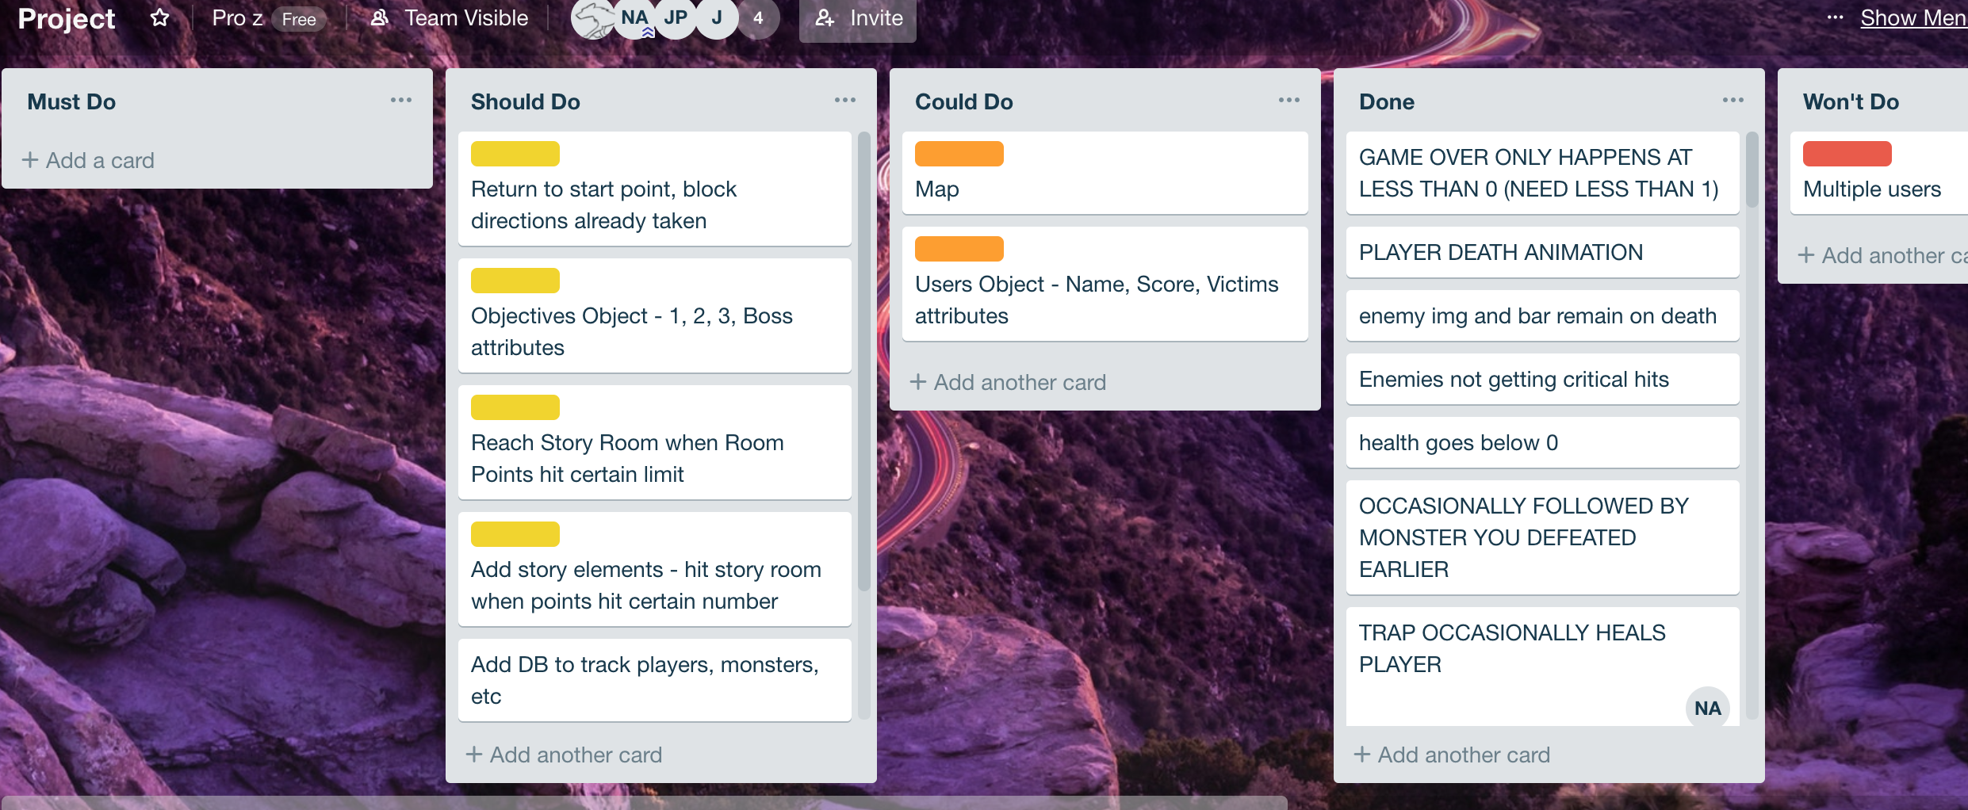

This shows progression during The Lost Prince. We used a MOSCOW board to track Must, Should, Could and Won’t tasks. By the end we’d achieved all of the Must and a few Shoulds.

| Unit | Ref | Evidence |  |
| --- | --- | --- | --- |

|  |  |  |
| --- | --- | --- |
| P | P.16 | Show an API being used within your program. Take a screenshot of:  * The code that uses or implements the API  * The API being used by the program whilst running |
|  |  | **Description:** |

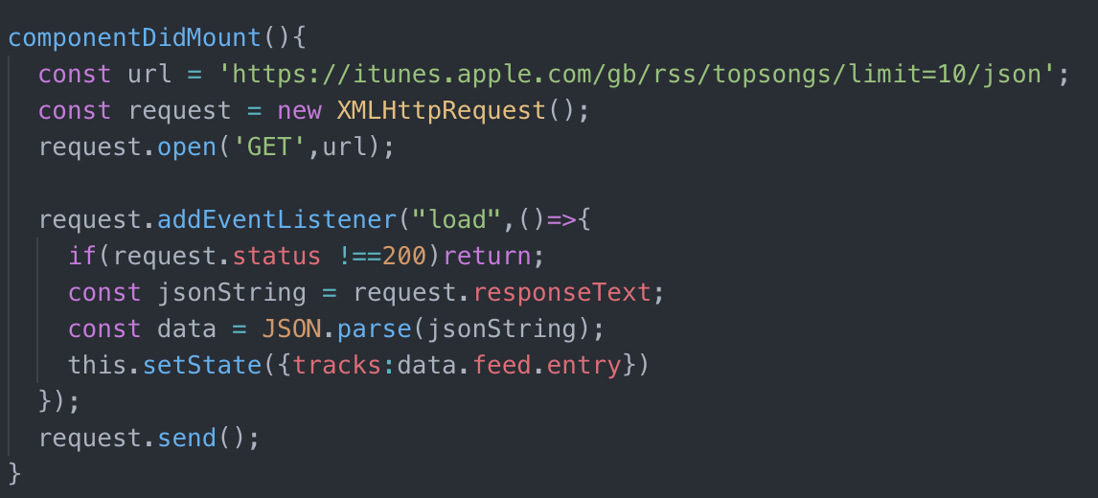

This is the UK Charts top 10 using the iTunes API to populate the list.

| Unit | Ref | Evidence |  |
| --- | --- | --- | --- |

|  |  |  |
| --- | --- | --- |
| P | P.18 | Demonstrate testing in your program. Take screenshots of:  * Example of test code  * The test code failing to pass  * Example of the test code once errors have been corrected  * The test code passing |
|  |  | **Description:** |

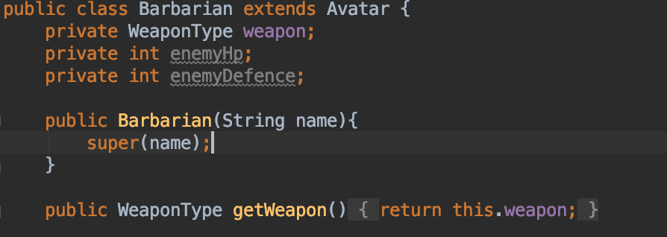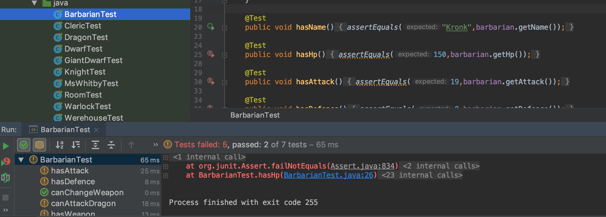

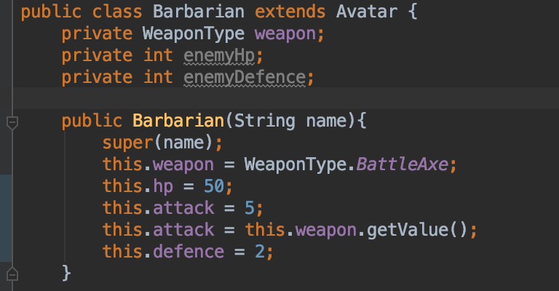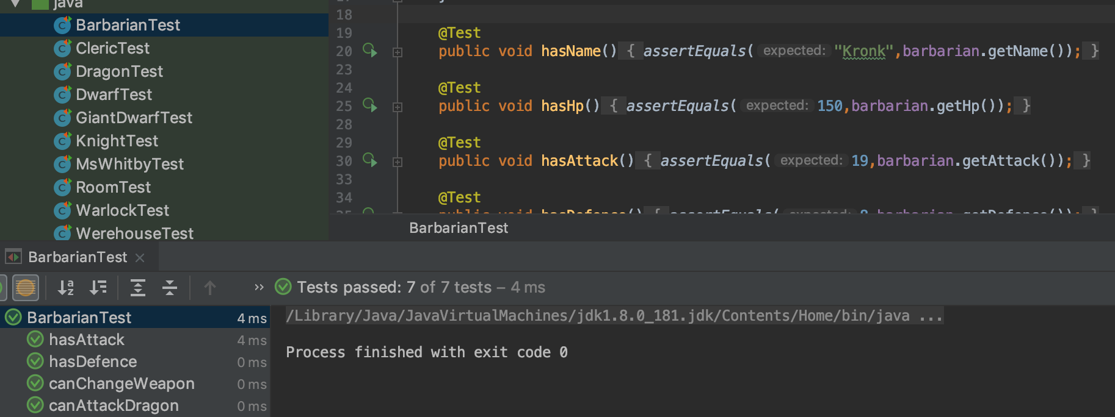

This is a bit of code from Son of the Lost Prince. In the first set, the base stats had been set, but Character Class modifiers hadn’t been set. This is rectified in the second set of images.

| Unit | Ref | Evidence |  |
| --- | --- | --- | --- |

|  |  |  |
| --- | --- | --- |
| P | P.1 | Take a screenshot of the contributor’s page on Github from your group project to show the team you worked with. |
|  |  | **Description:** |

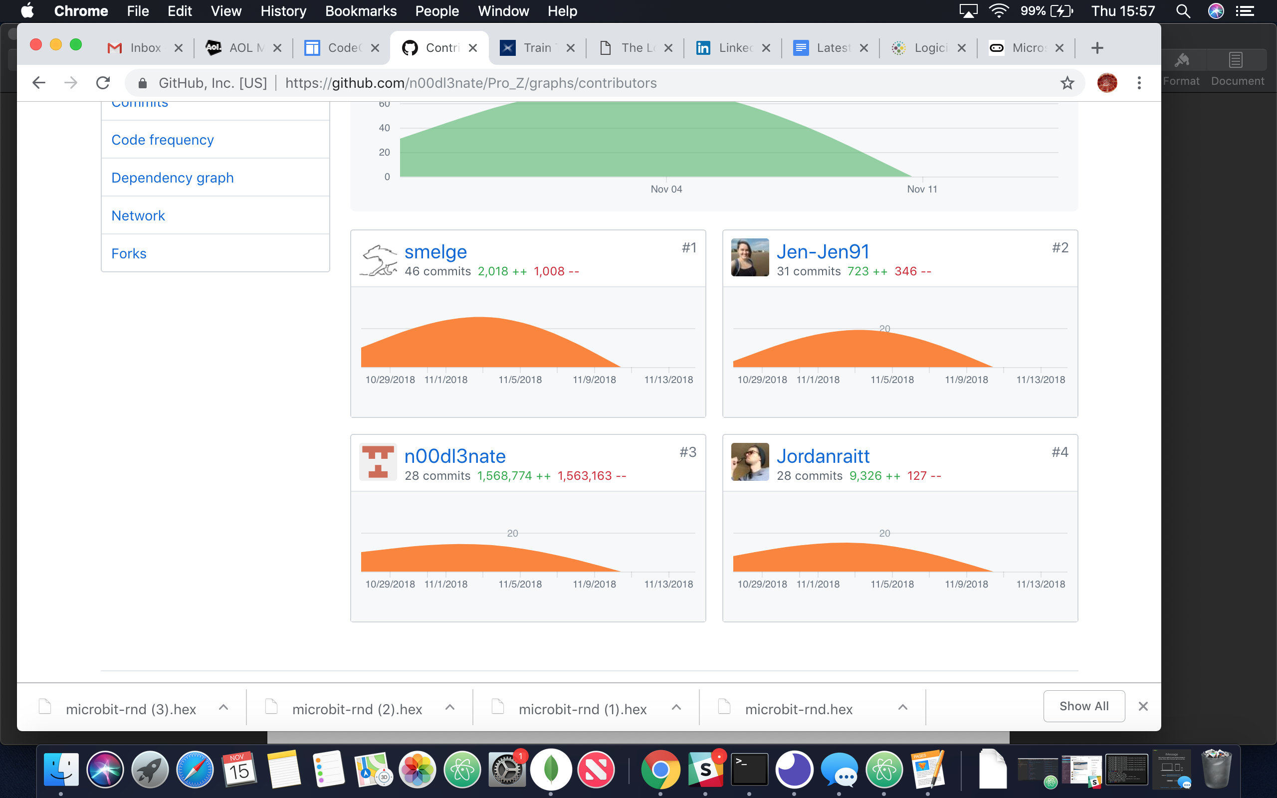

Over the course of the week long project, all 4 contributors of the group worked on producing a playable game.

| Unit | Ref | Evidence |  |
| --- | --- | --- | --- |

|  |  |  |
| --- | --- | --- |
| P | P.2 | Take a screenshot of the project brief from your group project. |
|  |  | **Description:** |

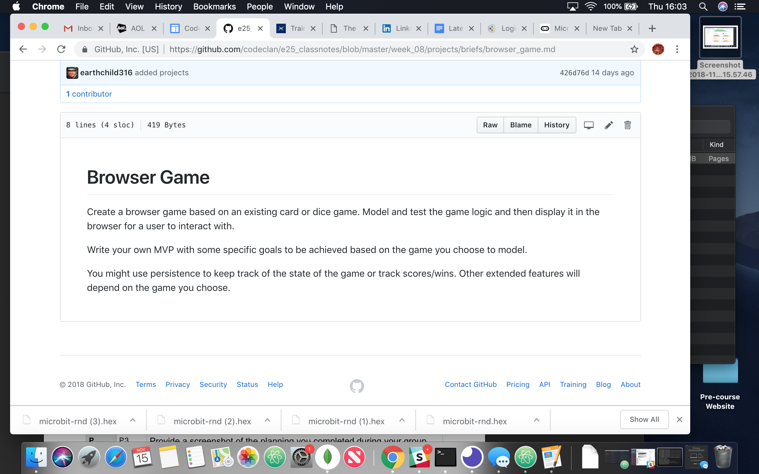

We settled on a browser game based on text RPGs. After some robust discussion, it was decided that instead of a linear game with each new room completely programmed, we would aim for procedural generation of rooms, items and monsters encountered. A basic framework should have been a simple task, allowing us to achieve the MVP early on, so we could focus on extensions to increase the playable aspects of the game.

| Unit | Ref | Evidence |  |
| --- | --- | --- | --- |

|  |  |  |
| --- | --- | --- |
| P | P.3 | Provide a screenshot of the planning you completed during your group project, e.g. Trello MOSCOW board. |
|  |  | **Description:** |

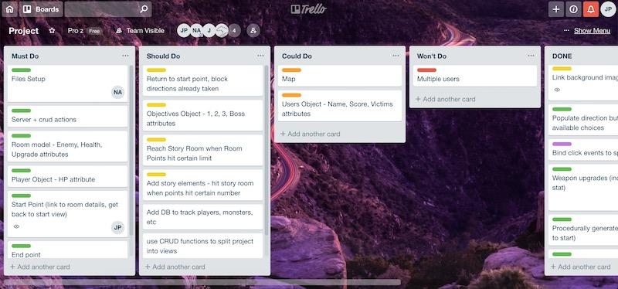

The MVP we planned for was a simple room generation, with the player being able to navigate to an end point while tracking what items they have picked up along the way.

Extensions added in story elements, combat mechanics, and other fun stuff, allowing for a game with high replayability.

| Unit | Ref | Evidence |  |
| --- | --- | --- | --- |

|  |  |  |
| --- | --- | --- |
| P | P.4 | Write an acceptance criteria and test plan. |
|  |  |  |

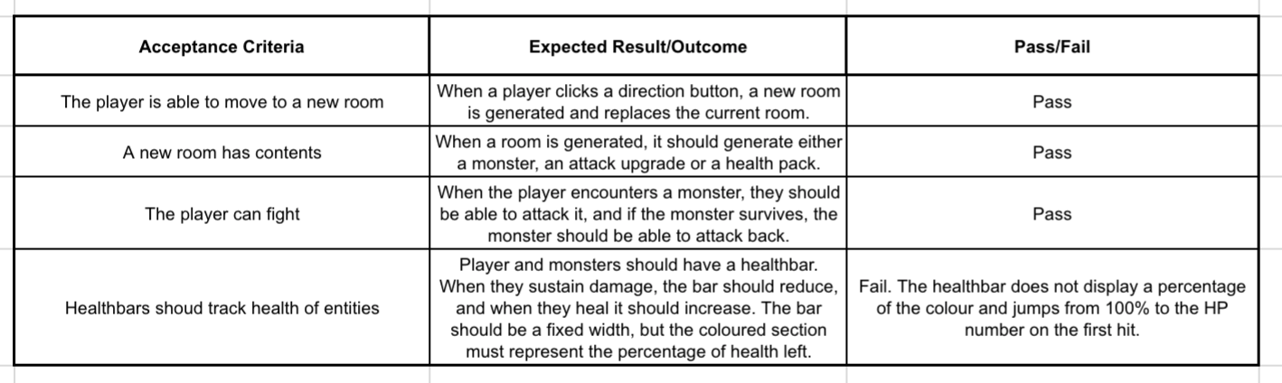

This is some of the acceptance criteria for The Lost Prince. At the end of the project we were able to get most basic functions working, however there was still a bug in the healthcare code.

| Unit | Ref | Evidence |  |
| --- | --- | --- | --- |

|  |  |  |
| --- | --- | --- |
| P | P.7 | Produce two system interaction diagrams (sequence and/or collaboration diagrams). |
|  |  | **Description:** |

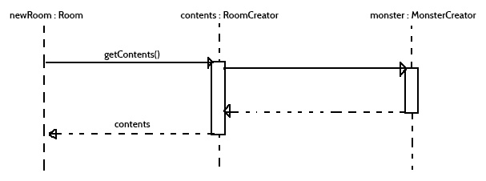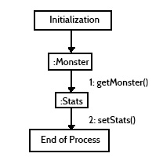

The top diagram is a sequence diagram for generating the contents of a room in an RPG.

The one to the left is a collaboration diagram showing how a monster is initialised.

| Unit | Ref | Evidence |  |
| --- | --- | --- | --- |

|  |  |  |
| --- | --- | --- |
| P | P.8 | Produce two object diagrams. |
|  |  | **Description:** |

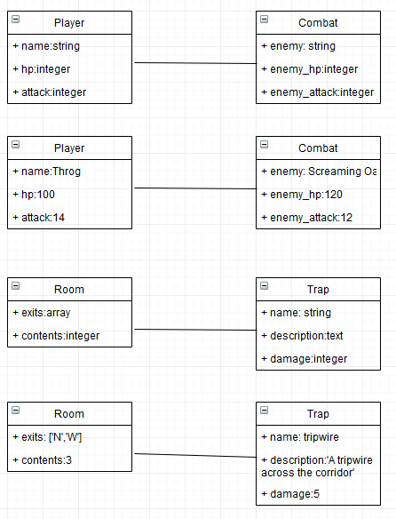

These two sets of class and object diagrams show player and combat objects, and rooms with traps.

| Unit | Ref | Evidence |  |
| --- | --- | --- | --- |

|  |  |  |
| --- | --- | --- |
| P | P.17 | Produce a bug tracking report |
|  |  | **Description:** |

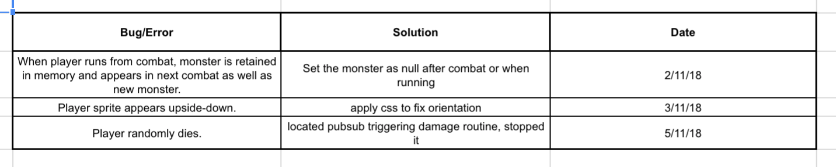

These bugs were from the Lost Prince and show some issues that cropped up and were fixed.

| Unit | Ref | Evidence |  |
| --- | --- | --- | --- |

|  |  |  |
| --- | --- | --- |
| I&T | I.T.7 | The use of Polymorphism in a program and what it is doing. |
|  |  | **Description**: |

This is a shop that sells musical instruments and books. In this, the ISell interface is used to handle all types of stock with their own unique variables. This means that only one interface is required instead of two different bits of code to add each type of item. The method allows us to stick to a DRY methodolgy and not repeat similar bits of code.

| Unit | Ref | Evidence |  |
| --- | --- | --- | --- |

|  |  |  |
| --- | --- | --- |
| A&D | A.D.5 | An Inheritance Diagram |
|  |  | **Description:** |

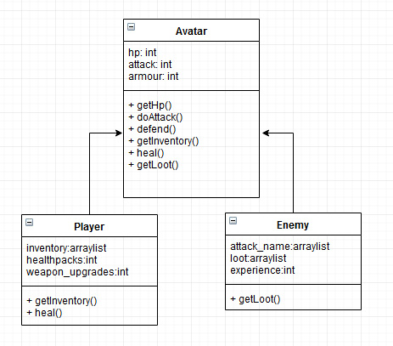

This inheritance diagram shows classes for Player and Enemy, as well as the main Avatar class. Avatar contains some functions that can be used for either child class, but inherits specific functions to handle the unique attributes of the children.

| Unit | Ref | Evidence |  |
| --- | --- | --- | --- |

|  |  |  |
| --- | --- | --- |
| I&T | I.T.1 | The use of Encapsulation in a program and what it is doing. |
|  |  | **Description:** |

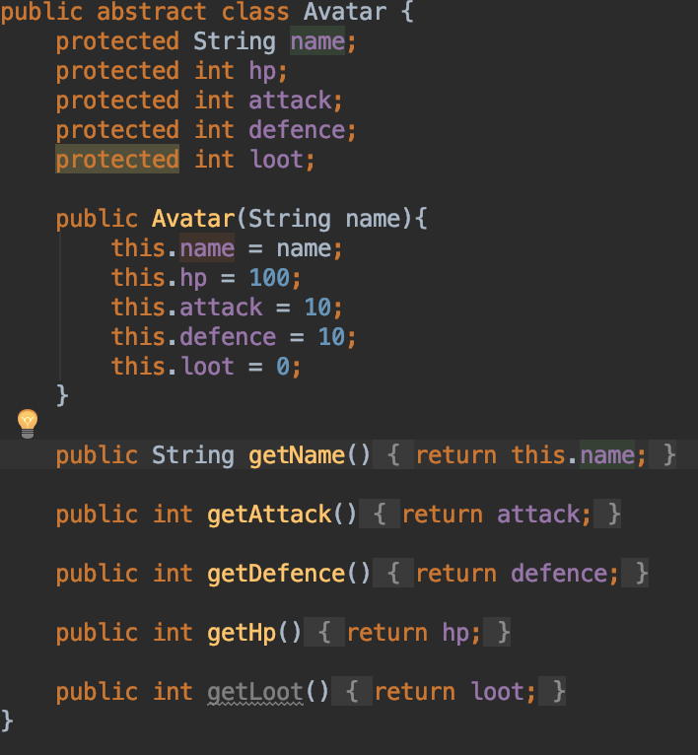

Going back to the Son of the Lost Prince, this shows Encapsulation in action. This is a way of making sure a variable cannot be directly accessed, having to go through a getter first. In this example, all the protected variables are encapsulated. Their values can only be got by using functions such as getAttack().

| Unit | Ref | Evidence |  |
| --- | --- | --- | --- |

|  |  |  |
| --- | --- | --- |
| I&T | I.T.2 | Take a screenshot of the use of Inheritance in a program. Take screenshots of:  *A Class  *A Class that inherits from the previous class  *An Object in the inherited class  *A Method that uses the information inherited from another class. |
|  |  | **Description:** |

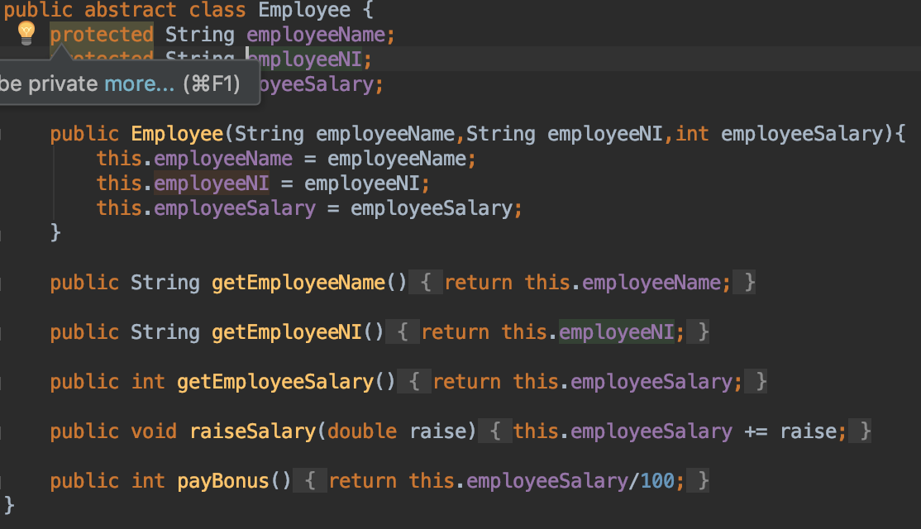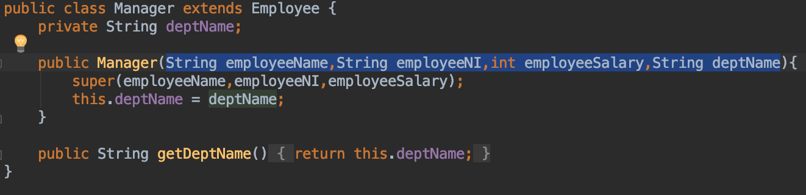

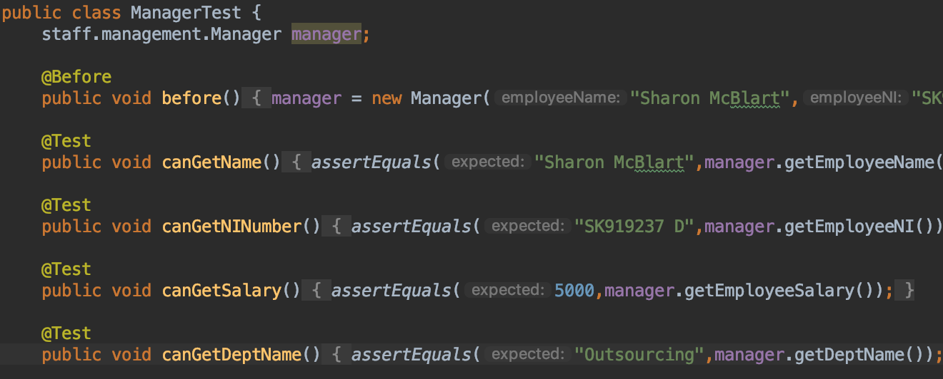

This shows the Employee class being set up with the main methods that pertain to all employees. It is then extended through the Manager class which adds its own variables.

All of the methods are available when you run them in the manager class as they have been inherited.

| Unit | Ref | Evidence |  |
| --- | --- | --- | --- |

|  |  |  |
| --- | --- | --- |
| P | P.9 | Select two algorithms you have written (NOT the group project). Take a screenshot of each and write a short statement on why you have chosen to use those algorithms. |
|  |  | **Description:** |

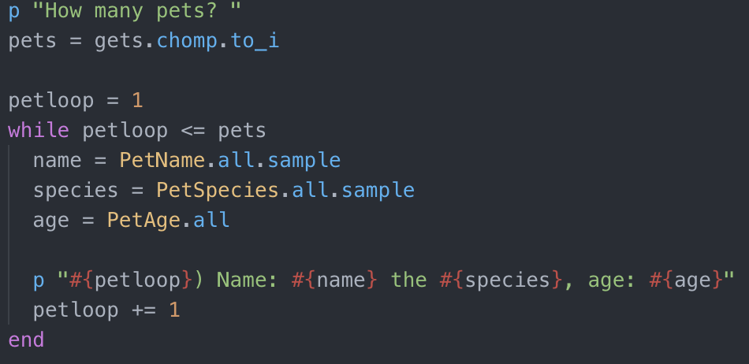

This first algorithm is part of a Pet Adoption Agency project done in Ruby. Multiple pets were required, so rather than manually creating a few pets to go in the database, I spend much more time making a pet randomiser. It accesses another file containing 2 arrays, one for name, one for species and a randomiser for age. To allow weighting for more popular species over rarer species, the species was added multiple times depending on how popular it is as a pet. The whole lot can be found here: <https://github.com/smelge/the_animaliser>

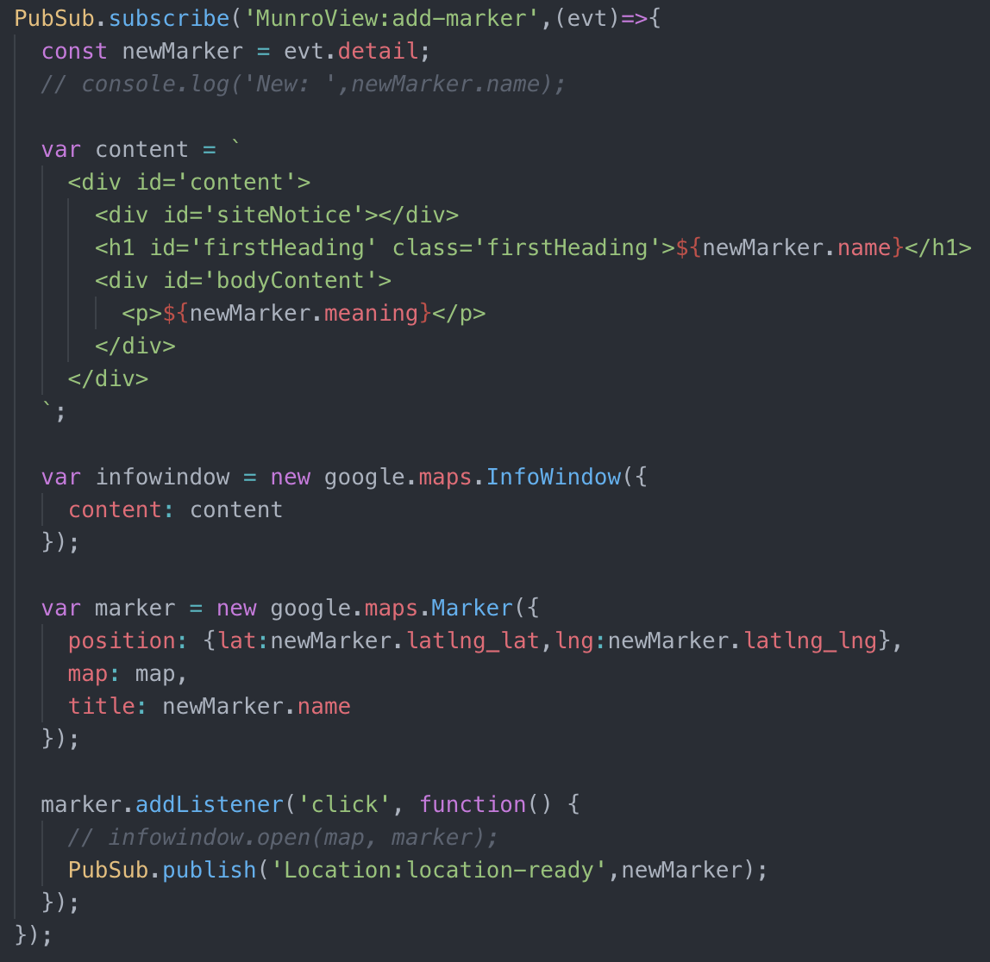This algorithm on the other hand comes from a Lab to use the Publish/Subscribe model to display information on Munros using an API to get all the data.

While this was a paired lab, once we completed the MVP, my partner decided to split off and work on frontend and css. I realised the API provided latitude and longitude for each Munro. This algorithm takes that latitude and longitude and adds it to a Google Map, as well as sets up a popup window that activates when the marker is clicked on, containing some information on that Munro.

I have chosen the first algorithm, as I feel it’s an interesting bit of code to produce results that could be done manually in no time, but is still fun to play with just for the random combinations you get.

The second was chosen because it shows a way of working through an api and doing a complex task such as adding markers and info to a map.